Sam Tenney

Homework 9

Section 2

1. Stroop Effect
2. The objective of the experiment was to test whether interferences have an effect or not on our ability to read, in this case, a list of colors.
3. There were 100 college students who were split up into groups of 50. One group performed the readings in one order while the other group did it in a different order. Subjects were asked to name the colors as they appeared in a regular reading line as quickly as possible. Subjects were also asked to correct errors when they made one.
4. The response variable: Amount of time to complete the task in seconds.
5. The factors and levels that were studied: Sex (male, female), word list type (Naming color test (NC), Naming color of word test where the color of the print and the word are different (NCWd)), college classification (1st yr, 2nd yr, 3rd yr, 4th yr, graduates)
6. Controls: The order in which the lists were read. All subjects were seated by a window to help control for lighting. The way the words were read, errors were corrected, and the timing were the same for each subject.
7. Nuisance factors: effort of the subjects.
8. The experimenters tested if there was an interaction between male and female subjects and their times. They found that when the NC test was done, females performed much better than males with a difference of 8.2 seconds, while the NCWd test didn’t show any significant difference of only 3.6 seconds.
9. We want to know whether shape or color make a bigger difference in how our minds process information. We tested having to match shapes of all the same color versus matching colors with the same shapes to see which one had a faster time on average.
10. The null hypothesis is that there is no difference between shapes and colors in how fast we process the objects we are matching (Ho: no difference between tests). The alternative hypothesis is that there is a difference between how our minds process shapes and colors (Ha: there is a difference between tests).
11. Response variable: the total amount of time (in milliseconds) it took the subject to place all the shapes in the correct spots.

Factors (levels): Shape and color setting (same color/different shape, different color/same shape), Timer display (yes, no)

Experimental unit: Students who completed each task

1. We need to control for the environment that we perform the tasks. We all decided to do it in a quiet room without distractions. Each of us will also perform the task on a track pad rather than a mouse pad.

|  |  |  |  |
| --- | --- | --- | --- |
| Design for Color-Shape Experiment | | | |
| Block Run | Task | Timer | Time (sec) |
| 1 | Shape-same color | Yes |  |
| 2 | Color-same shape | Yes |  |
| 3 | Shape-same color | No |  |
| 4 | Color-same shape | No |  |

|  |  |  |  |  |  |
| --- | --- | --- | --- | --- | --- |
| Check Sheet for Color-Shape Experiment | | | | | |
| Run | Block | Block Run | Task | Timer | Time (sec) |
| 1 | Thomas | 1 | Color-same shape | No | 63.840 |
| 2 | Thomas | 2 | Shape-same color | No | 69.069 |
| 3 | Thomas | 3 | Shape-same color | Yes | 69.869 |
| 4 | Thomas | 4 | Color-same shape | Yes | 59.477 |
| 5 | Sam | 1 | Shape-same color | No | 54.020 |
| 6 | Sam | 2 | Color-same shape | Yes | 51.949 |
| 7 | Sam | 3 | Color-same shape | No | 48.160 |
| 8 | Sam | 4 | Shape-same color | Yes | 50.113 |
| 9 | Wade | 1 | Shape-same color | No | 61.000 |
| 10 | Wade | 2 | Color-same shape | No | 60.997 |
| 11 | Wade | 3 | Shape-same color | Yes | 57.159 |
| 12 | Wade | 4 | Color-same shape | Yes | 57.176 |
| 13 | Cory | 1 | Color-same shape | No | 59.205 |
| 14 | Cory | 2 | Shape-same color | Yes | 55.484 |
| 15 | Cory | 3 | Shape-same color | No | 55.556 |
| 16 | Cory | 4 | Color-same shape | Yes | 52.770 |

1. Each of the subjects (us students) have different abilities when it comes to recognizing the shapes and colors, so we want each of our results to be in a separate block to account for the variation in our different abilities.

stroop <- read.table(text = "Run Block blockRun Task timerDisplay Time  
1 Thomas 1 Color No 63.84  
2 Thomas 2 Shape No 69.069  
3 Thomas 3 Shape Yes 69.869  
4 Thomas 4 Color Yes 59.477  
5 Sam 1 Shape No 54.02  
. . .   
12 Wade 4 Color Yes 57.176  
13 Cory 1 Color No 59.205  
14 Cory 2 Shape Yes 55.484  
15 Cory 3 Shape No 55.556  
16 Cory 4 Color Yes 52.77  
", header = TRUE, sep = "")

1. # Calculate summary statistics  
   aggregate(Time~Task+timerDisplay+Task*timerDisplay, data = stroop, FUN = mean)

aggregate(Time~Task+timerDisplay+Task*timerDisplay, data = stroop, FUN = sd)

|  |  |  |  |
| --- | --- | --- | --- |
| Average and SD Time Taken to Complete Task | | |  |
| Task | timerDisplay | Avg Time (in seconds) | Standard Deviation |
| Color-same shape | No | 58.0505 | 6.8643 |
| Shape-same color | No | 59.9113 | 6.8001 |
| Color-same shape | Yes | 55.3430 | 3.5865 |
| Shape-same color | Yes | 58.1563 | 8.3670 |

After calculating the mean time taken to complete each task, it appears that the task completed the quickest, on average, was the different-colors-same-shape task at 55.343 seconds. This task also had the smallest spread in times between blocks. The slowest task completed was the different-shape-same-color task at 59.9113 seconds.

1. 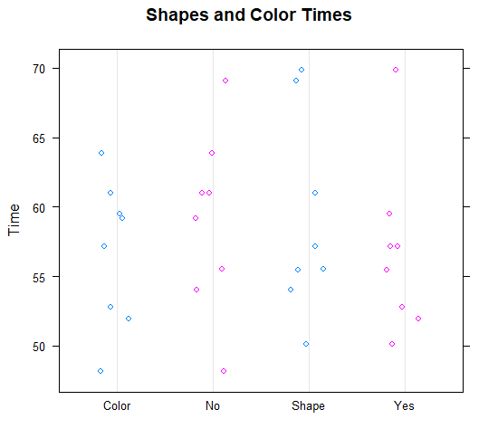

The distributions seem to be the same for the most part across the different factors. It does seem that times tended to be a little faster when the timer was displayed and when participants were asked to match the different colors for the same shape. There is one outlier for when the timer displayed that seemed to take about 10 seconds longer than the other times tested with the timer displayed. All the graphs seem symmetric.

1. The ANOVA model for the shape-color data is yijk = µ + αi + βj + γij + ηk + ɛ­ijk. yijk is the time (in seconds) for the kth student (block) of the ith task level (shape-same color, color-same shape) and the jth level timer display level (yes or no). The variable µ is the grand mean of all the times it took to complete the tasks. The variable αi is the treatment effect for the ith task level. The variable βj is the treatment effect for the jth timer display level. The variable γij is the interaction effect for the ith task level and the jth timer display level. ηk is the block effect for the k­th student block. The error for the kth student with ith task level and the jth timer display level is represented by ɛ­ijk.

|  |  |  |  |  |  |
| --- | --- | --- | --- | --- | --- |
| ANOVA Table Including Blocks | | | | | |
| Source | Df | Sum Sq. | Mean Sq. | F-STAT | p-Value |
| Task | 1 | 21.85 | 21.85 | 2.38 | 0.16 |
| timerDisplay | 1 | 19.91 | 19.91 | 2.17 | 0.17 |
| Block | 3 | 446.05 | 148.68 | 16.19 | < 0.001 |
| Task:timerDisplay | 1 | 0.91 | 0.91 | 0.10 | 0.76 |
| Residuals | 9 | 82.64 | 9.18 |  |  |

The difference between the students’ times are statistically significant since the p-value is less than 0.001. The difference in times for the different tasks and timer settings are not significant enough to assume they make a difference in time to complete the task.

1. Yes, the blocking factor is an important source of variability. Most of the variability in our results came from our blocking factor as it was the only statistically significant factor.

|  |  |  |  |  |  |
| --- | --- | --- | --- | --- | --- |
| ANOVA Table Excluding Blocks | | | | | |
| Source | Df | Sum Sq. | Mean Sq. | F-STAT | p-Value |
| Task | 1 | 21.85 | 21.85 | 0.50 | 0.50 |
| timerDisplay | 1 | 19.91 | 19.91 | 0.45 | 0.51 |
| Task:timerDisplay | 1 | 0.91 | 0.91 | 0.02 | 0.89 |
| Residuals | 12 | 528.69 | 44.06 |  |  |

My conclusions stay the same as none of the other factors are statistically significant. Their p-values are much higher now though. There isn’t much variance between the different task settings when you don’t account for the different students. If you look at the dot plot in part j, you can see that the results are similar across the different settings. That is why the p-value doesn’t show any statistically significant results.

1. Assumptions:

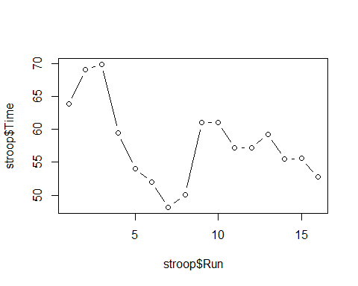**Index Plot to Check Independence**

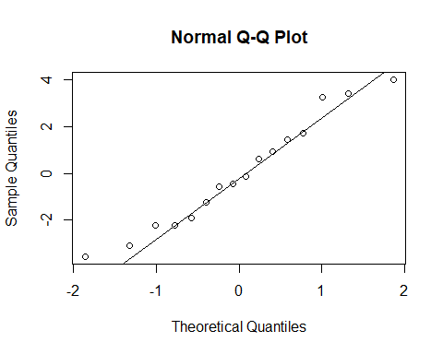It appears that there is a pattern in the index plot. Every four points are bundled near one another representing the tests for each student. There isn’t independence among each block of students.

The Normal QQ Plot appears to be a straight line, so we can assume the data is normal.

Based on the standard deviations calculated in part i, 8.36 / 3.58 > 2 so the variances are not constant.

# Check mean of residuals to see if it equals 0  
stroop$resids <- resid(stroopMod)  
mean(stroop$resids)

## [1] -1.040834e-16

The mean of the residuals is close enough to 0 to assume that the mean is equal to 0.

It appears that the assumptions for independence and a constant variance are not met.

1. Had the assumption parameters been met, we could conclude that there was not a statistically significant difference in the amount of time it took to perform each different task with the different time settings. The p-values for each of the main effects and the interaction effects were all greater than 0.05, while the blocking factor of each student was less than 0.001. The only variance we can see came from the variance in each student’s abilities compared to the other students.